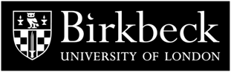

**THE MURRAY SEMINAR ON MEDIEVAL AND RENAISSANCE ART**

**The Department of History of Art at Birkbeck presents a series of seminars on medieval and renaissance art, supported by the bequest established in memory of Professor Peter Murray, the Department's founder.** [**http://www.bbk.ac.uk/events-calendar**](http://www.bbk.ac.uk/events-calendar)

**18 October**

**Kim Woods ‘Speaking Sculptures’**

**13 November**

**Zoe Opacic ‘From Sacroscape to Cityscape: Images of Central European Towns in Late Medieval Sources’**

**6 December**

**Cecily Hennessy ‘Mary Magdalene in Byzantium’**

**Seminars are held at 5pm in The Keynes Library, Birkbeck School of Arts, 43, Gordon Sq., London, WC1H OPD. A break at 5.50pm is followed by discussion and refreshments.**