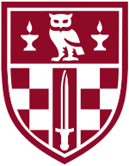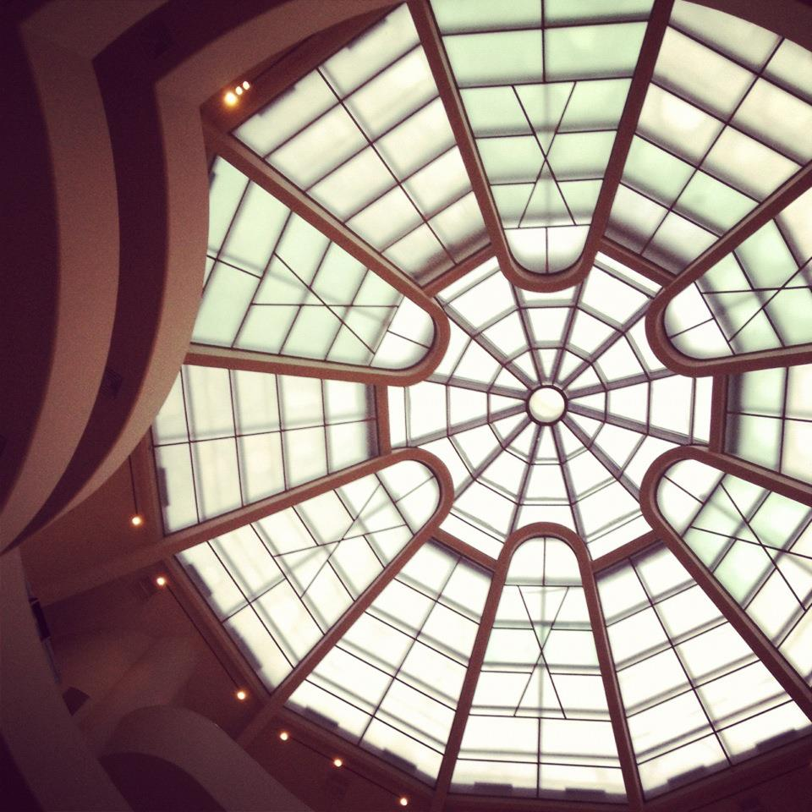

43 Gordon Square, London, WC1H 0PD

Birkbeck, School of Arts

First Meeting: 11 October 2017, 6pm

Room: Keynes Library (Room 114)

Birkbeck School of Arts: Research Student Collective

# Looking for a place to discuss your research?

## Join our informal researchers’ forum. Meeting monthly, the Collective gives PGR students across the school a friendly space in which to practice, present, explore and question your work in progress