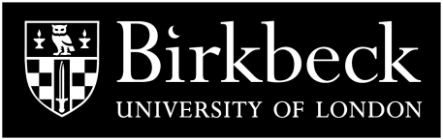

**THE MURRAY SEMINAR ON MEDIEVAL AND RENAISSANCE ART**

**The Department of History of Art at Birkbeck presents a series of seminars on medieval and renaissance art, supported by the bequest established in memory of Professor Peter Murray, the Department's founder.** [**http://www.bbk.ac.uk/events-calendar**](http://www.bbk.ac.uk/events-calendar)

**10 May Joanna Cannon**

**Second Thoughts: Redating the Frescoes by the Maestro di San Francesco at Assisi**

**7 June Dorigen Caldwell**

**'"There is nothing better than to live after death": seeking immortality in *cinquecento* Rome'**

**28 June Robert Maniura**

**Jaume Huguet, decoration and innovation in fifteenth-century Iberian art**

**Seminars are held at 5pm in Birkbeck’s School of Arts (The Keynes Library, 43, Gordon Sq., London, WC1H OPD). A break at 5.50pm is followed by discussion and refreshments.**