The Architectural Association
Art and Architecture
Artists’ Talks Series Organised by Parveen Adams

PIERRE-JEAN GILOUX
‘urban landscapes’
Friday October 21st 2016 6.30 – 8.00
Pierre-Jean Giloux works with the ideas of the Japanese Metabolists who wanted to revolutionise the cities of the future along the lines of organic growth. They produced innovative architectural designs and urban planning proposals but their mega-structures remained unrealised. Pierre-Jean Giloux’s Invisible Cities reconstructs their architectural projects on video starting with images of real Japanese cities and moving towards new virtual forms. His four videos are mixtures of photographic and digital images and the sounds of four Japanese cities and their suburbs –Tokyo, Yokohama, Osaka and Kyoto. He works with the composer Lionel Marchetti whose sound work parallels the pace of progressive metamorphoses of the landscape.
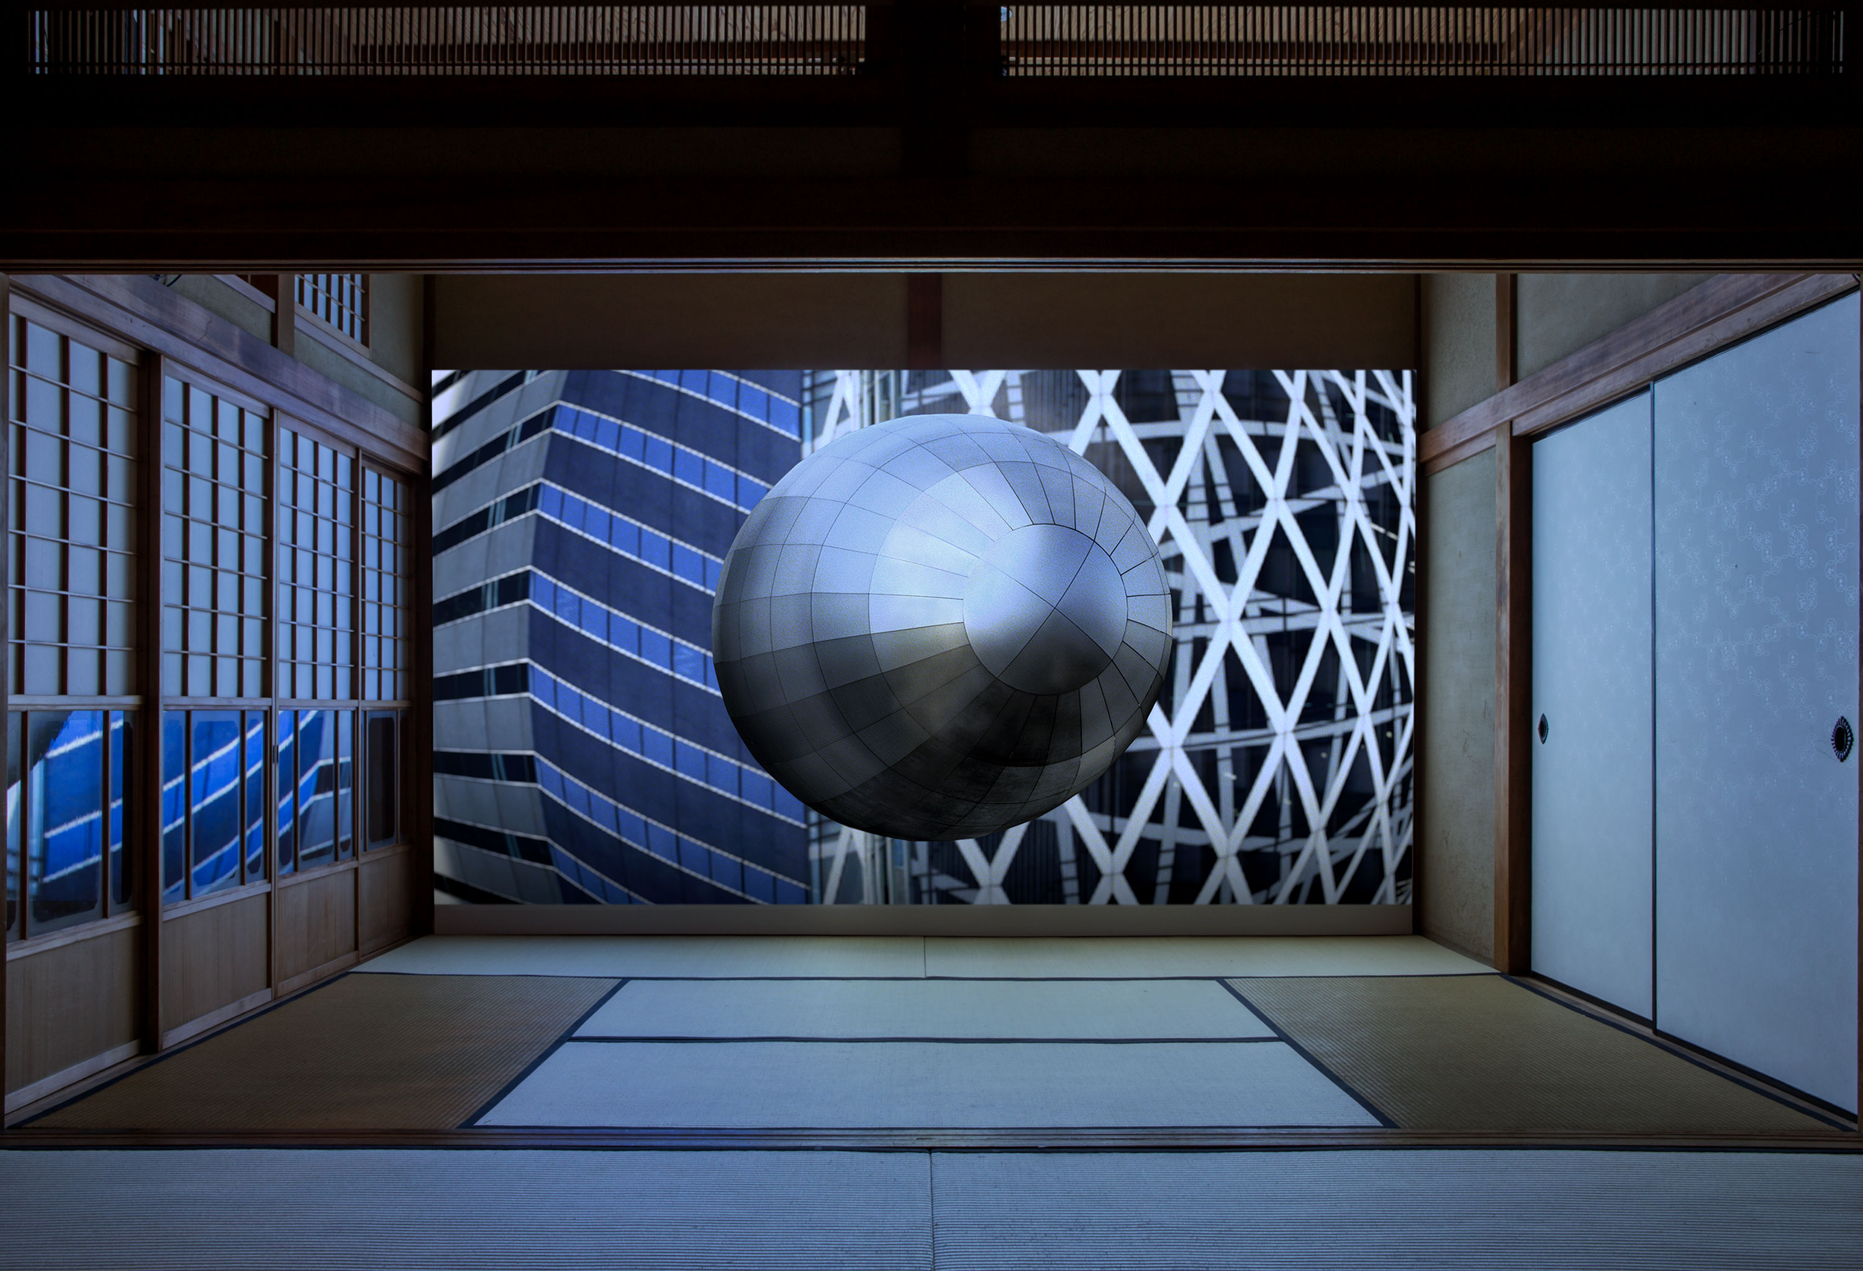
Giloux has shown at the Cinema du Centre Georges Pompidou in Brusssels; FIAC in Paris; Centre d’art contemporain de basse Normandie. In many festivals - Beyond the Sounds festival in Hong Kong; BIM Buenos Aires; Video France Collection in Yokohama, Japan; Bitfilm Festival in Hamburg and in galleries in Lyon, Berlin and Paris. In 2016 he participated in Artists and Architecture at Emily Harvey Foundation in New York and at Le Carré in Kyoto. His most recent publication is Dimension Variable, Paris.

Mark Cousins Friday Lectures - MIRACLES - 5.00 – 6.00
Architectural Association 34-36 Bedford Square, London WC1B 3ES

