The Architectural Association
Art and Architecture
Artists’ Talks Series Organised by Parveen Adams

MARK LEWIS
Invention
Friday October 28th 2016 6.30 – 8.00
Mark Lewis is a Canadian artist who lives and works in London. His film and digital moving image works are frequently depictions of everyday life produced through the use of cinematographic techniques and they make subtle and often accidental allusion to the wider tradition of film, photography and painting. His most recent works include a series of films shot in the Korean DMZ and the film project Invention that imagines a contemporary city with no cinema or moving image devices. In this scenario, the city itself is the cinema, focusing on the intense concentration of moving bodies, shadows and reflections. The project culminated in a feature film entitled Invention which premiered at Toronto International Film Festival in 2015.
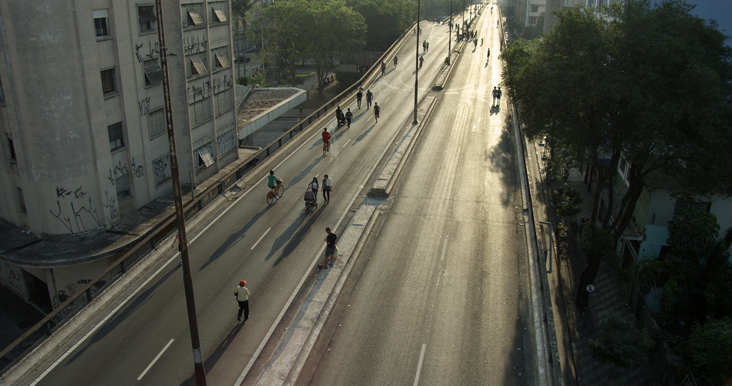
Above and Below the Minhocão, Mark Lewis, 2014. 5k transferred to 2k, 11'14''. Film still courtesy and copyright the artist.
Lewis is a co-founder and co-director of Afterall, a publication and research organisation based in Central Saint Martins College of Art and Design, London. In 2009 he represented Canada at the 53rd Venice Biennale and he has exhibited at the Van Abbemuseum (Eindhoven), National Gallery of Canada, MoMA (New York), BFI Southbank (London), Centre Pompidou (Paris) amongst others.

Mark Cousins Friday Lectures - MIRACLES - 5.00 – 6.00
Architectural Association 34-36 Bedford Square, London WC1B 3ES

