Redefining Allegory: The Meaning of Allegory Now

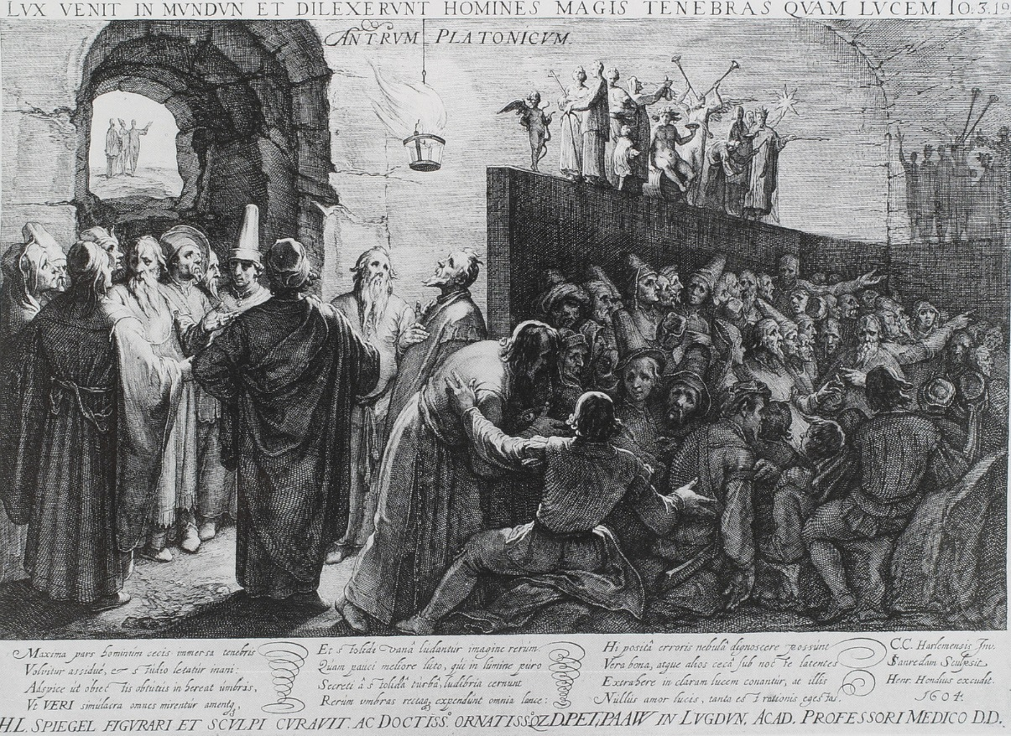

Call for papers for a one day conference
24th September 2016
Queen Mary University of London

Keynotes from
Michael Silk (King’s College London)
and Jeremy Tambling

Deadline for 300 word abstract/proposals for 20 minute papers: 8th August 2016

redefiningallegory2016@gmail.com

Even after “allegory studies” develops as a discipline in its own right, what allegory is and what allegory means is still a contentious issue. This conference aims to address 20th century and contemporary theoretical applications for allegory, most notably in the work of Walter Benjamin and Paul De Man, and contrast them with the voices of scholars who consider this allegory a misinterpretation of a historically bound category.

What persists in allegory is its investment in a hidden meaning beyond itself, as Angus Fletcher explains in a recent essay “Allegory without Ideas” (2006). This dominant feature is consistent from allegory’s historical function as a mediator between the individual and the divine. However, in modern art practices, literatures and discourse given to secular inspiration, the singular and universal category of “the divine,” which defined Medieval and Renaissance uses of allegory in religious practice, is recognised in contemporary allegorical incarnations only as a trace of the Platonic ideas that underpins a western Christian doctrine. With contemporary allegory, we are stuck on our side of what Fletcher calls “the semiotic wall” of allegorical signification that separates the represented object from its cognition. Rather than being overcome through hermeneutics, “the wall” of allegory resists interpretation and seems to transmute any reading into irony.
In this respect, Walter Benjamin described allegory as ‘a particular aesthetic form of understanding truth (Wahrnehmen)’ (Asja Lacis qtd. in Buck-Morss 1989; 15), where allegorical form is meant to reveal and devalue the methods of how truth is constructed. For Paul De Man, writing in The Rhetoric of Temporality, any ‘understanding’ of a text is only ‘the impossibility in all writing and speaking, of saying what is intended, and of having a single intention, as well as the impossibility of reading what has been written.'

This conference aims to provide a platform to address issues surrounding the more recent definitions of allegory. What could the defining features of allegory be? Are there any possible benefits of the later definitions for more traditional historical led discussions of allegorical art? And finally, can there be a unified definition fit for interdisciplinary cross-cultural application that is both relevant to allegory as such and the allegorical in theory?

We invite papers from practitioners (poets, performers, artists, educators) and scholars in a range of fields including, but not limited to, English and comparative literature, linguistics, drama, media studies, cultural studies, psychology and philosophy.

We encourage submissions for 20 min papers, panels and workshops which reflect on the value of allegory in contemporary culture as well as presentations that consider possible problems inherent in more recent definitions of allegory. We also welcome speakers interested in novel methodologies for devising allegorical meaning from any historical period or from cultural traditions beyond the western canon.

Possible themes include:

* Comparative religion – What continuities across faiths find allegorical expression?
* Temporality - What happens to the subjective experience of time when allegory is invoked?
* Morality and ethics – How does allegory function to regulate and instruct behaviour?
* Affect – What aesthetic affects are persistent in allegorical works?
* Ritual – Is all allegory theological and can it maintain relevance in secular form?
* Historical continuity – How do we relate to allegorical meanings in artwork that no longer directly illuminates our daily life?
* Allegory and revision - Are pastiche and irony are tools to mediate and complicate allegorical standards?
* Psychoanalysis – Is allegory a form of ‘working through’ the past? Alternatively, is it an impulse of societal discontent?
* Post-Colonialism – Is there an inherent hierarchical power structure in allegorical works and is preference given to allegorical expression when cultures come into conflict?

“Redefining Allegory: The Meaning of Allegory Now,”
School of English and Drama,
Queen Mary University of London, Mile End Road, London E1 4NS.
The conference is made possible by The Doctoral College Initiative Fund, Queen Mary University of London and is organised by PhD candidates John L. Dunn and Agnieszka Puchalska.

