Belonging & Transgression
UCL Society for Comparative Cultural Inquiry (SCCI)
Postgraduate Conference - 23rd-24th June 2016
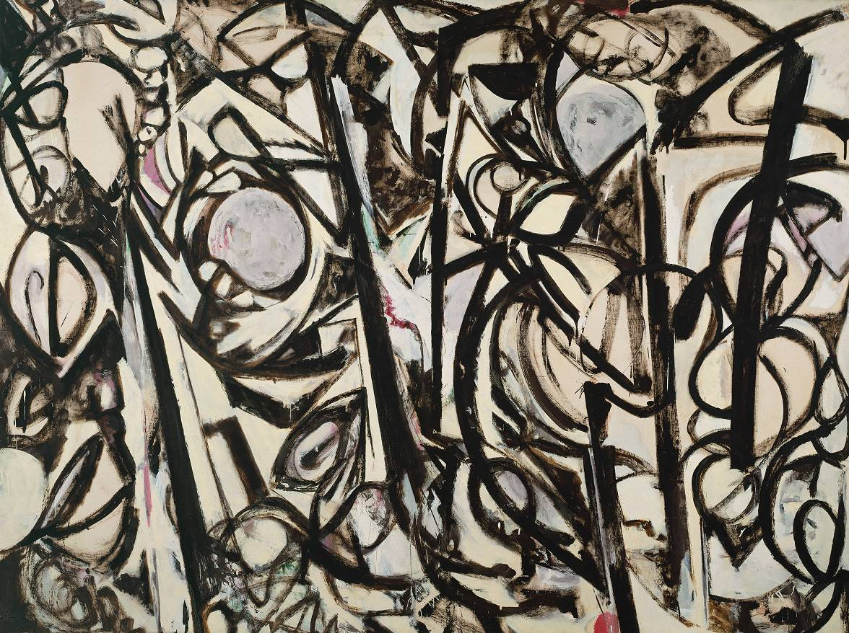
Image: Lee Krasner, ‘Gothic Landscape’, 1961
‘Belonging and Transgression’ invites the interdisciplinary scholar to consider the interactions and conflicts that structure our fields of study, to explore how these concepts operate within our (inter)cultural inquiries, and how we confront them in our academic work.
The consideration of relations and tensions is central to interdisciplinary and comparative study in the Arts and Humanities. Understanding narratives of belonging, and how they are constructed, developed or transgressed, informs our study of culture and also allows us to reflect on how we both build and break connections across disciplines. The ways in which communities – imagined and practiced – construct ideas of belonging and transgression are integral to how we engage with our studies, and in how we communicate as scholars within the Arts and Humanities and beyond.
For the Fifth Annual Interdisciplinary Postgraduate Conference, UCL’s Society for Comparative Cultural Inquiry invites proposals for papers relating to the connected theme(s) of ‘Belonging and Transgression’ from scholars across a wide spectrum of disciplines. We welcome papers dealing with past and contemporary sources from Europe and beyond, from any disciplinary or transdisciplinary perspective. We especially welcome proposals from researchers focusing on interdisciplinary subjects that look outside the traditional remit of the Humanities. Proposals for panel discussions, performances, artistic installations and workshops are also welcome.
Conference Speakers will deliver a 15-20 minute presentation, with 10-15 minutes for questions. We invite submissions from all disciplines, including but not limited to:
Literary Criticism and Theory; Film Studies and Photography; Politics and Political theory; History; Sociology; Modern Languages; Philosophy; Economics; Art; Psychology/Psychoanalysis; Cultural Studies; Translation Studies; Gender studies.
The aim of this conference is to interrogate and explore the dynamics of belonging and transgressing in the Arts and Humanities from perspectives which might encompass the following:
- How identities are constructed or dismantled in literature, film, visual art, or media
- How art, philosophy, or text can transgress context, practice, or form
- Belonging and transgression through linguistics, languages and translation
- How transgression and belonging interact in issues of gender and sexuality
- Psychological approaches to questions of belonging and transgression
- Belonging and transgression in international politics, migration, and post-colonialism
- Spatial, geographical or architectural dynamics of belonging or transgressing
- How artistic, cultural, and social movements constitute “belonging”
- Reflections on belonging and transgression in academic disciplines
Please send an abstract (250 words), 5 keywords and a brief biographical statement (50 words) to culturalinquiry.ucl@gmail.com. Deadline for submissions is Friday 22nd April.

