Birkbeck Eighteenth-Century Research Group
Birkbeck College, University of London

Lecture by Prof. Tita Chico
‘Aesthetics, Mediation, and Difference:
British Literature and Science’
6pm, Tuesday 10th November
Keynes Library, School of Arts, 43 Gordon Square
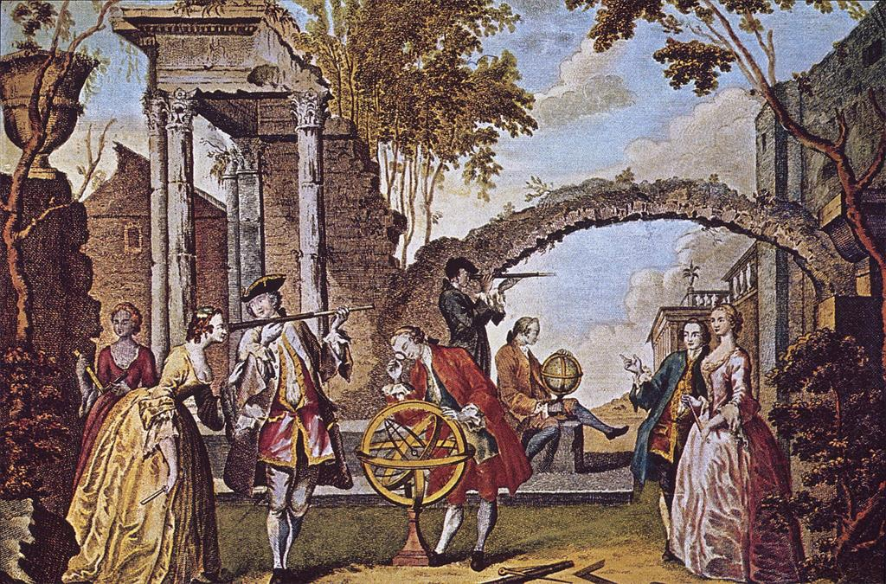

The Birkbeck Eighteenth-Century Research Group is delighted to announce a forthcoming lecture by Tita Chico, Associate Professor in the English Department at the University of Maryland.

Professor Chico is the author of Designing Women: The Dressing Room in Eighteenth-Century English Literature and Culture (2005), and co-editor of Atlantic Worlds in the Long Eighteenth Century: Seduction and Sentiment (2012), with Toni Bowers. She is also editor of The Eighteenth Century: Theory and Interpretation. This talk relates to her current book project, Experimentalism: Literary Knowledge and Science in the British Enlightenment.
All very welcome!
For further information, please contact Kate Retford: k.retford@bbk.ac.uk

