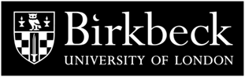

**THE MURRAY SEMINAR ON MEDIEVAL AND RENAISSANCE ART**

**All seminars are held at 5pm in The Keynes Library, Birkbeck School of Arts, 43, Gordon Sq., London, WC1H OPD. A break at 5.50pm is followed by discussion and refreshments.**

**17 January: Carol Richardson**

***Britons and Anglo-Saxons in Sixteenth-Century Rome: the 1580s fresco cycle at the English College***

**13 February: Emanuele Lugli**

***Chasing Absence: The Body of Christ and the Measures to Enter in Touch with it***

**14 March: Luca Palozzi**

***‘And the great lion walks through his innocent grove’. A cross-disciplinary study of lion paw prints in Giovanni Pisano’s Pisa pulpit***

**This series of seminars on medieval and renaissance art is supported by the bequest established in memory of Professor Peter Murray, the Department's founder.** [**http://www.bbk.ac.uk/events-calendar**](http://www.bbk.ac.uk/events-calendar)